**Accessing your child’s immunization record from Skyward.**

* Log-in to Skyward Family Access from your school’s web page. This works best on a desktop or laptop computer.
* At the top of the page Under “Family Access”, choose whose record you want to view (if you have more than one student in the district).

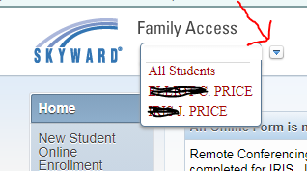

* On the menu on the left side, click on “Health Info”

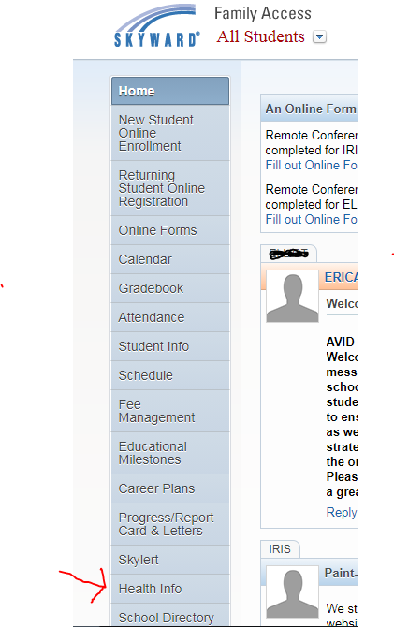

* Under the heading “Health Information” click “Display Options”

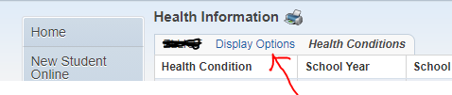

* Choose “Show Vaccinations”

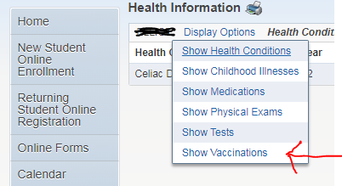

* Your student’s current shot record will be displayed.

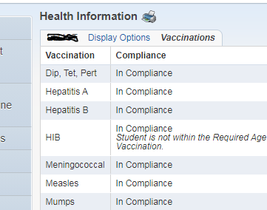

* If a student is out of compliance, this will show up in red. These are the immunizations your child needs.

To Print: Click on the printer icon.

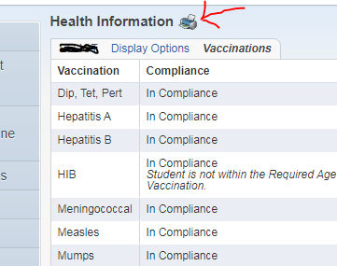

The copy you print will be a much better view of the shot records than the version the nurse can print for you.